# DENGUE PREDICTION USING FUZZY LOGIC

A Project Report

Submitted in Partial Fulfillment of the Requirement for the Award of the Degree

# BACHELOR OF TECHNOLOGY (COMPUTERSCIENCEANDENGINEERING)



Submitted by Tejash Rai



DEPARTMENT OF COMPUTER SCIENCE & ENGINEERINGSHAMBHUNATH INSTITUTE OF ENGINEERING ANDTECHNOLOGY,PRAYAGRAJ

**JUNE 2024**



## **CANDIDATE’SDECLARATION**

I TEJASH RAI 2001620100091, students of B.Tech of Computer Science and Engineering hereby declared that I own the full responsibility for the information, results etc. provided in this project titled “DENGUE PREDICTION USING FUZZY LOGIC” submitted to Dr. A.P. J Abdul Kalam Technical University, Lucknow for award of B.Tech (Computer Science and Engineering) degree. I have taken care in all respect to honor the intellectual property right and have acknowledged the contributions of others for using them in this academic purpose. I further declared that in case of any violation of intellectual property right or copyright, I as the candidate would be fully responsible for the same. Our supervisor and institute should not be held for full or partial violation of copy right if found at any stage of our degree.

Date: 14/05/2024

**Student Name: TEJASH RAI**

CERTIFICATE

This is to certify that the project work entitled “DENGUE PREDICTION USING FUZZY LOGIC”, submitted by TEJASH RAI 2001620100091,, to the Dr. A.P.J. Abdul Kalam Technical University, Lucknow, for the partial fulfilment of the requirement for the award of Bachelor of Technology (Computer Science and Engineering) degree, is a record of student’s own study carried out under my supervision and guidance.

This project has not been submitted to any other university or institution for the award of any other degree.

SUPERVISOR

Dr PAVAN

Professor

Department of CSE

SIET,PRAYAGRAJ



ACKNOWLEDGEMENT

I TEJASH RAI 200162010091… am grateful to the management of Shambhunath Institute of Engineering & Technology for providing me an opportunity to undertake our major project in its prestigious college. I am grateful and thankful to Dr. PAVAN helped us in every way possible. They put me under good supervision which helped in learning a lot of new things about the project and its various applications. They also provided me with all the necessary information needed. I also take the opportunity to offer our sincere thanks and deep sense of gratitude to Dr PAVAN Sir for attending us throughout the course of this project. I must make special mention of our H.O.D. Dr. ROHIT BAKSHI Sir for providing us a platform to complete our project successfully. I would thank all the lab maintenance staff for providing assistance in various H/W & S/W problem encountered during course of our project. I am also very thankful to respected project coordinator who gave me an opportunity to present this project.

ABSTRACT

Dengue fever is a disease which is hard to identify, it is only detectable when the patient is at the critically ill. This study uses a fuzzy logic approach for the patient to get further notification if they are suspected with dengue fever. The study will suggest the patient whether to go or not to go to the hospital for further diagnosis. A doctor working in the vector unit was selected to be interviewed as a domain expert for this project as to obtain data about the dengue disease. Fuzzy logic will take part as an inference engine in this study that is applied to the rules of a knowledge base within a fuzzy or a crisp rule-based to determine whether the patient is suspected with dengue fever or not. The results and findings from the study had shown that the technique of fuzzy logic can contribute a reliable result in order to notify the disease. Human subject has been used to test the system Dengue fever is a mosquito-borne infectious disease threatening more than a hundred tropical countries of the world. The heterogeneity of mosquito bites of human during the spread of dengue virus is an important factor that should be considered while modeling the dynamics of the disease. However, traditional models assumed homogeneous transmission between host and vectors which is inconsistent with reality. The transmission rate and recovery rate of the disease are considered as fuzzy numbers. The dynamical behavior of the system is discussed with different amounts of dengue viruses.

## **LISTOFABBREVIATIONS**

|  |  |
| --- | --- |
| **SYMBOLS** | **DESCRIPTION** |
| FL | Fuzzy Logic |
| FIS | Fuzzy Inference System |
| FIRs | Fuzzy inference rules |
| FRB | Fuzzy Rule Base |
| FN | Fuzzy Number |
| FLT | Fuzzy Logic Tool |
| Dpp | Data Pre-Processing |
| I/P & O/P | Input and Output |
| HR | Human Reasoning |
| HF | Hemorrhagic Fever |
| MATLAB | Matrix Laboratory |
| FLP | Fuzzy Logic Approach |
| SLR | Statutory Liquidity Ratio |
| AI | Artificial Intelligence |
| ES | Expert System |
| H/W & S/W | Hardware and Software |
| ROC | Receiver Operating Characteristic |
| LS | Literature Survey |

**CONTENTS**

|  |  |
| --- | --- |
| **CANDIDATE’SDECLARATION** | i |
| **CERTIFICATE** | ii |
| **ACKNOWLEDMENT** | iii |
| **ABSTRACT** | iv |
| **LISTOFABBREVIATION** | v |
| **TABLEOFCONTENTS** | vi |
| **LISTOFFIGURES** | vii |
| **CHAPTER1:INTRODUCTION** | **1-4** |
| 1.1Dengue Fever | 1-3 |
| 1.2Fuzzy Logic | 3-4 |
| 1.3 Dengue Fever using Fuzzy Logic | 4 |
| 1.4 Objective | 4 |
| **CHAPTER2:BACKGROUNDANDRELATEDWORK** | **5-6** |
| 2.1Background | 5 |
| 2.2 Related Work | 5 |
| 2.3 Literature Survey | 6 |
| **CHAPTER3:PROPOSED APPROACH (FIS)** | **7-14** |
| 3.Proposed Approach | 7-8 |
| 3.1Dataset | 8-9 |
| Input and Output | 9-13 |
| 3.2Process | 13-14 |
| **CHAPTER4:METHODOLOGY** | **15-17** |
| 4.1Method | 15 |
| 4.2Tools | 15-16 |
| 4.3Fuzzy Logic Toolbox | 16-17 |
| **CHAPTER 5: RESULT & ANALYSIS** | **18-23** |
| 5.1 Result | 18-23 |
| **CHAPTER 6: CONCLUSION & FUTURE WORK** | **24-28** |
| 6.1 Conclusion | 24 |
| 6.2 Future Work | 24-25 |
| 6.3 Reference | 26-28 |

# LISTOFFIGURES

|  |  |  |
| --- | --- | --- |
| **Figure No.** | **Figure Description** | **Page No.** |
| Fig.1 | Fuzzy Logic | 3 |
| Fig.2.1 | Membership function of input1(Fever) | 10 |
| Fig.2.2 | Membership function of input2(Headache) | 10 |
| Fig.2.3 | Membership function of input3(Joint pain) | 11 |
| Fig.2.4 | Membership function of inpur4(Nausea) | 11 |
| Fig.3.1 | Rule viewer of Dengue_ P | 12 |
| Fig.3.2 | Rule viewer of Dengue _P | 13 |
| Fig.4 | Steps of Fuzzy Logic | 14 |
| Fig.5 | Fuzzy Logic Toolbox | 16 |
| Fig. 6 | Fuzzy Logic Toolbox For MATLAB | 17 |
| Fig.7 | Fuzzy Logic Toolbox views & Membership function editor | 17 |
| Fig.8 | Dengue Prediction System | 18 |
| Fig. 9 | Fuzzy Logic Designer | 19 |
| Fig. 10 | Membership function of output | 20 |
| Fig. 11 | Rule Editor | 20 |
| Fig. 12.1 | Rule viewer of Dengue _P | 21 |
| Fig. 12.2 | Rule viewer of Dengue _P | 22 |
| Fig. 13 | Surface view of Joint pain & Fever | 23 |

**CHAPTER 1**

**INTRODUCTION**

Dengue fever is a disease that is being spread by Aedes mosquitoes. These mosquitoes carried out the dengue virus even when they are in their larva state. They pray on human blood and will leave a liquid on the victim’s skin. These liquids are the ones that cause the fever where it holds the dengue virus. Some may just seem it as a normal flu because it is hard to detect whether if it is a dengue or a normal fever. There are no major symptoms at the early stage and the symptoms will only visible when the victim’s state is critical. Many clinical manifestations and abnormalities in the laboratory results of dengue fever are found in other common infections, such as scrub typhus, murine typhus, or just a fever. It is very vital to detect the dengue fever at the early stage and this study will apply fuzzy logic as an approach for detect the dengue fever. Thus, a lack of awareness and uncertainty of the early notification of the disease among people, the dengue fever has caused many deaths. Thus, early notification is important in preventing the disease from spreading. So far, there are still no special tools for notification of dengue fever. Consequently, a study of fuzzy logic is worth the effort in contributing new knowledge and insight towards the development of tool in the dengue notification system.

* 1. **DENGUE FEVER**

Dengue (DENG-gey) fever is a mosquito-borne illness that occurs in tropical and subtropical areas of the world. Mild dengue fever causes a high fever and flu-like symptoms. The severe form of dengue fever, also called dengue hemorrhagic fever, can cause serious bleeding, a sudden drop in blood pressure (shock) and death. Millions of cases of dengue infection occur worldwide each year. Dengue fever is most common in Southeast Asia, the western Pacific islands, Latin America and Africa. But the disease has been spreading to new areas, including local outbreaks in Europe and southern parts of the United States. Researchers are working on dengue fever vaccines. For now, in areas where dengue fever is common, the best ways to prevent infection are to avoid being bitten by mosquitoes and to take steps to reduce the mosquito population.

Dengue fever is a mosquito-borne tropical disease caused by the dengue virus.[1] Symptoms typically begin three to fourteen days after infection.[2] These may include a high fever, headache, vomiting, muscle and joint pains, and a characteristic skin itching and skin rash.[1][2] Recovery generally takes two to seven days.[1] In a small proportion of cases, the disease develops into a more severe dengue hemorrhagic fever, resulting in bleeding, low levels of blood platelets and blood plasma leakage, or into dengue shock syndrome, where dangerously low blood pressure occurs.

Dengue is an acute viral illness caused by RNA virus of the family Flaviviridae and spread by Aedes mosquitoes. Presenting features may range from asymptomatic fever to dreaded complications such as hemorrhagic fever and shock[4]. A cute-onset high fever, muscle and joint pain, myalgia, cutaneous rash, hemorrhagic episodes, and circulatory shock are the commonly seen symptoms. Oral manifestations are rare in dengue infection; however, some cases may have oral features as the only presenting manifestation. Early and accurate diagnosis is critical to reduce mortality.

Although dengue virus infections are usually self-limiting, dengue infection has come up as a public health challenge in the tropical and subtropical nations. This article provides a detailed overview on dengue virus infections, varied clinical manifestations, diagnosis, differential diagnosis, and prevention and treatment.

As many as 9 states of India have been gripped by dengue since the beginning of this year, which are as follows: -

* Delhi recorded 2,100 on October 26, 2022, the Municipal Corporation of Delhi said October 31, 2022. Over 1,200 of the cases were in October itself — the highest for the month in five years.
* West Bengal recorded its worst dengue outbreak in five years, with cases topping 42,000 by the end of October 2022.
* Kolkata recorded its weekly highest new infections (745) in the week ending October 27, 2022.
* Kerala saw the highest dengue toll (20) in the country and had over 7,000 cases by October 18, 2022.
* Uttar Pradesh recorded more than 18,000 cases since the beginning of 2022, according to the state health department. Prayagraj and Pratapgarh recorded 882 cases as of October 31, 2022 and six deaths.
* There were around 4,000 cases in Bihar by the third week of October, three fourths of which were from Patna.
* More than 8,500 infections and nine deaths were recorded in Punjab till October.
* Odisha recorded some 5,500 cases, with a little over 2,000 in Bhubaneswar alone.
* So far, Tamil Nadu has recorded over 4,900 cases, according to the Department of Public Health of the State Government of Tamil Nadu. The number of new cases (616) recorded in October was 10 percent higher than in September.
* Dengue fever causes a high fever — 104 F (40 C) — and any of the following signs and symptoms.
* Headache
* Joint pain
* Vomiting
* Pain behind the Eyes

Warning signs of severe dengue fever — which is a life-threatening emergency — can develop quickly. The warning signs usually begin the first day or two after your fever goes away, and may include:

* Severe stomach pain
* Bleeding from your gums or nose
* Blood in your urine or vomit
* Bleeding under the skin, which might look like bruising
* Difficult or rapid breathing

**1.2 Fuzzy Logic**

The term fuzzy refers to things that are not clear or are vague. In the real world many times we encounter a situation when we can’t determine whether the state is true or false, their fuzzy logic provides very valuable flexibility for reasoning. In this way, we can consider the inaccuracies and uncertainties of any situation. Fuzzy Logic is a form of many-valued logic in which the truth values of variables may be any real number between 0 and 1, instead of just the traditional values of true or false. It is used to deal with imprecise or uncertain information and is a mathematical method for representing vagueness and uncertainty in decision-making

Fuzzy Logic is based on the idea that in many cases, the concept of true or false is too restrictive, and that there are many shades of gray in between. It allows for partial truths, where a statement can be partially true or false, rather than fully true or false. Fuzzy Logic is used in a wide range of applications, such as control systems, image processing, natural language processing, medical diagnosis, and artificial intelligence.Fuzzy Logic is implemented using Fuzzy Rules, which are if-then statements that express the relationship between input variables and output variables in a fuzzy way. The output of a Fuzzy Logic system is a fuzzy set, which is a set of membership degrees for each possible output value.

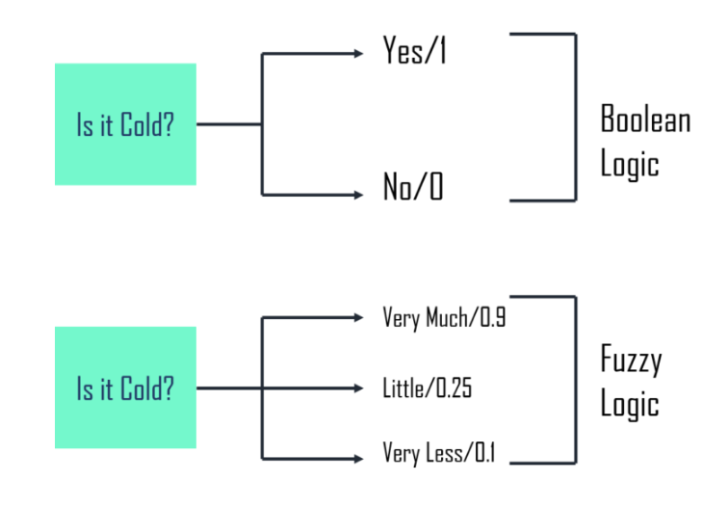**Fuzzy Logic** (FL) is a method of reasoning that resembles **human reasoning**. This approach is similar to how humans perform decision making. And it involves all intermediate possibilities between **YES** and **NO**.

**Fig 1 – Fuzzy Logic**

In summary, Fuzzy Logic is a mathematical method for representing vagueness and uncertainty in decision-making, it allows for partial truths, and it is used in a wide range of applications. It is based on the concept of membership function and the implementation is done using Fuzzy rules. In the boolean system truth value, 1.0 represents the absolute truth value and 0.0 represents the absolute false value. But in the fuzzy system, there is no logic for the absolute truth and absolute false value. But in fuzzy logic, there is an intermediate value too present which is partially true and partially false.

* 1. **Dengue fever using fuzzy logic**

Dengue fever is a mosquito-borne viral disease that affects millions of people worldwide. Fuzzy logic can be used as a tool for dengue prediction by taking into account various factors and their degrees of membership.

It's important to note that developing an accurate dengue prediction model requires extensive data analysis, domain expertise, and iterative refinement. Fuzzy logic is just one of the approaches that can be used, and its effectiveness depends on the quality and relevance of the input variables, the rules, and the overall model design.

The purposed of this research is to help the user, in this case, patients doing consultations for self-diagnosis dengue fever. It will act as an expert in this case, doing interviews with the patients. It also provides easier ways for patients to get consultancy with an expert and also reduce the doctor’s burden of replacing the doctor’s role as the expert in diagnosis the disease with a fuzzy logic algorithm. In day so, the consultation provided by this research will be in the form of notified the users whether they have infected with dengue fever and some treatment suggestion. It provides many benefits both to the doctors and patients.

the relationship between the occurrence of Aedes mosquito populations and cases of dengue is not clearcut, and that a fuzzy-logic approach is worth considering. In contrast to crisp logic, Zadeh proposed the fuzzy set theory, which avoids the use of discrete true-or false syllogisms, thus conferring a conceptual malleability suitable for real-life situations. Solski and Kandiah emphasized the continuous character of nature, which implies that living beings are distributed in time and space essentially in a gradual and fuzzy manner. A fuzzy logic approach is consequently useful for processing and modelling environmental data. Tus, the application of fuzzy logic could be helpful to recognize the biogeographical vector-illness interaction and the dynamism in the risk of dengue occurrence, and to establish the biogeographical framework in which the disease occurs. Fuzzy logic led to the notion of environmental favourability, a concept related to, but different from, probability of occurrence. Favourability functions can be used in SDM, and are particularly helpful when models of several species are involved in the study, as they allow the comparison between models for species or cases differing in prevalence, using fuzzy logic tools.

**Objective**: There are the following three-fold objective given below:

1.To Study the soft computing technique Fuzzy Logic approach using fuzzy inference system

2. Create a Fuzzy logic model to Predict dengue and notify the patient suffering from dengue Fever or Not.

3. Using Matlab Fuzzy tool kit to implement Dengue Prediction Using FIS.

**CHAPTER 2**

**_____________________________________________________________**

Dengue prediction using fuzzy logic has gained attention due to its ability to handle uncertainty and imprecise data associated with dengue-related factors. Fuzzy logic allows the modeling of linguistic variables and fuzzy sets, providing a framework to analyze the complex relationships between environmental factors, mosquito population, and dengue incidence. Here is some background information and related work on dengue prediction using fuzzy logic:

**2.1 Background:**

Dengue fever is a mosquito-borne viral disease that affects millions of people worldwide. Predicting dengue outbreaks accurately can assist in implementing preventive measures, allocating resources, and reducing the impact of the disease. Fuzzy logic is a suitable approach for dengue prediction as it can capture the uncertainty and vagueness associated with factors such as temperature, humidity, rainfall, and mosquito population.

**2.2Related Work:**

" Sohidull Islam and T. Sabrinaproposes a hybrid approach combining fuzzy logic and time series analysis for dengue fever prediction. Fuzzy logic is employed to handle uncertainty, while time series analysis is used to capture temporal patterns in the data."Dengue Outbreak Prediction Using Fuzzy Logic and Machine Learning Techniques" by S. R. Balaji and R. Indra Gandhi: The authors propose a hybrid model that integrates fuzzy logic and machine learning techniques for dengue outbreak prediction. Fuzzy logic is utilized to handle imprecise data, while machine learning algorithms are employed to analyze historical data and predict future outbreaks.

"This research work presents a fuzzy rule-based system for dengue prediction. The system incorporates expert knowledge, linguistic variables, and fuzzy rules to model the relationship between environmental factors, mosquito population, and dengue incidence.

"A Fuzzy Inference System for Dengue Fever Prediction" by M. O. Ahmad, M. A. Rahim, and S. S. Ahmed: The authors develop a fuzzy inference system for dengue fever prediction based on temperature, humidity, and rainfall data. The fuzzy inference system utilizes fuzzy rules and membership functions to predict the likelihood of dengue fever outbreaks.

"This study presents a fuzzy inference system for dengue fever outbreak prediction. The system utilizes fuzzy sets, linguistic variables, and fuzzy rules to represent the input factors and determine the likelihood of dengue outbreaks based on historical data.

**2.3 LITERATURE SURVEY**

G Bhigu et al suggestedtransmission dynamics of dengue with the fuzzy SEIR-SEI compartmental model. The transmission rate and recovery rate of the disease are considered as fuzzy numbers. The

dynamical behavior of the system is discussed with different amounts of dengue viruses. Also, the fuzzy basic reproductionnumber for a group of infected individuals with different virus loads is calculated using Sugeno integral. Simulations are madeto illustrate the mathematical results graphically.

S Bhatt et al predicted dengue to be ubiquitous throughout the tropics, with local spatial variations in risk influenced strongly by rainfall, temperature and the degree of urbanization. Using cartographic approaches, we estimate there to be 390 million (95% credible interval 284-528) dengue infections per year, of which 96 million (67-136) manifest apparently (any level of disease severity). This infection total is more than three times the dengue burden estimate of the World Health Organization. Stratification of our estimates by country allows comparison with national dengue reporting, after taking into account the probability of an apparent infection being formally reported. The most notable differences are discussed. These new risk maps and infection estimates provide novel insights into the global, regional and national public health burden imposed by dengue.

N. K. Vaidya, X. Li, and F. B. Wang, study sensitivity of the basic reproduction number to the environmental temperature. We then introduce spatially heterogeneous temperature into the model and establish some important properties of dengue dynamics. In particular, we formulate two indices, mosquito reproduction number and infection invasion threshold, which completely determine the global threshold dynamics of the model. We also perform numerical simulations to explore the impact of spatially heterogeneous temperature on the disease dynamics. Our analytical and numerical results reveal that spatial heterogeneity of temperature can have significant impact on expansion of dengue epidemics. Our results, including threshold indices, may provide useful information for effective deployment of spatially targeted interventions.

R. N. Beers and S. M. Ciupe take Cross-reactive T cell responses induced by a primary dengue virus infection may contribute to increased disease severity following heterologous infections with a different virus serotype in a phenomenon known as the original antigenic sin. In this study, we developed and analyzed in-host models of T cell responses to primary and secondary dengue virus infections that considered the effect of T cell cross-reactivity in disease enhancement. We fitted the models to published patient data and showed that the overall infected cell killing is similar in dengue heterologous infections, resulting in dengue fever and dengue hemorrhagic fever. The contribution to overall killing, however, is dominated by non-specific T cell responses during the majority of secondary dengue hemorrhagic fever cases. By contrast, more than half of secondary dengue fever cases have predominant strain-specific T cell responses with high avidity. These results support the hypothesis that cross-reactive T cell responses occur mainly during severe disease cases of heterologous dengue virus infections.

**CHAPTER 3**

**______________________________________________________________**

**ProposedApproach(FIS) :-**

Fuzzy logic is an approach to variable processing that allows for multiple possible truth values to be processed through the same variable. Fuzzy logic attempts to solve problems with an open, imprecise spectrum of data and [heuristics](https://www.investopedia.com/terms/h/heuristics.asp) that makes it possible to obtain an array of accurate conclusions.

Fuzzy logic is designed to solve problems by considering all available information and making the best possible decision given the input.

Here's a basic outline of how fuzzy logic tool kit can be applied to dengue prediction:

**1. Identify input variables**: Determine the relevant factors that contribute to dengue prediction. These variables can include temperature, rainfall, humidity, population density, previous dengue cases, and other environmental factors.

**2**. **Define fuzzy sets**: Divide each input variable into linguistic terms or fuzzy sets. For example, temperature can be divided into "low," "medium," and "high" sets, and rainfall can be divided into "low," "moderate," and "high" sets. Assign membership functions to these sets, indicating the degree of membership for each input value.

**3**. **Create fuzzy rules**: Establish a set of fuzzy rules that define the relationship between the input variables and the predicted dengue risk. These rules can be formulated based on expert knowledge or historical data. For example, a rule could be "If temperature is high and rainfall is high, then dengue risk is very high."

**4**. **Fuzzify the inputs**: Convert the crisp input values (actual data) into fuzzy values by evaluating their membership functions. Each input variable will have a fuzzy value for each linguistic term.

**5. Apply the fuzzy rules**: Determine the activation level of each rule based on the fuzzy values of the input variables. Combine the activated rules to obtain a fuzzy output.

**6. Defuzzify the output**: Convert the fuzzy output into a crisp value by using a defuzzification method. Common defuzzification methods include centroid, max membership, and weighted average.

**7. Interpret the results**: The defuzzified output represents the predicted dengue risk level based on the input variables. This can be interpreted as low, medium, or high risk, for example.

**8. Refine and validate the model**: Continuously improve the fuzzy logic model by refining the fuzzy sets, rules, and membership functions based on feedback and validation against real-world data.

**Dataset:**Here's a continuation of the data set for dengue using fuzzy logic:

| **Nausea** | **Fever** | **Joint pain** | **Headache** | **Dengue Prediction** |
| --- | --- | --- | --- | --- |
| Low | Avg | Low | Low | No |
| Avg | Low | Avg | Avg | Maybe |
| Avg | Avg | Avg | Low | No |
| High | High | Avg | High | Maybe |
| Avg | Avg | High | Avg | No |
| Avg | High | Avg | High | Yes |
| Low | High | Low | Avg | Maybe |
| Avg | Avg | Low | Low | No |
| High | High | High | High | Yes |

In this extended data set, we have included additional instances with varying values for the temperature, humidity, rainfall, mosquito population, and dengue prevalence. Each instance represents a specific set of conditions, and fuzzy logic is used to assign membership grades to each variable based on their respective fuzzy sets.

The fuzzy sets for the variables can be defined as follows:

**Temperature:** Fuzzy sets like "Hot," "Moderate," and "Cool" can be defined based on temperature ranges.

**Humidity:** Fuzzy sets like "High," "Medium," and "Low" can be defined based on humidity levels.

**Rainfall:** Fuzzy sets like "Heavy," "Moderate," and "Light" can be defined based on the amount of rainfall.

**Mosquito Population:** Fuzzy sets like "High," "Medium," and "Low" can be defined based on the estimated number of mosquitoes.

**Dengue Prevalence:** Fuzzy sets like "High," "Medium," and "Low" can be defined based on the reported number of dengue cases.

By using fuzzy logic, you can capture the uncertainty and imprecision in the data, as well as model the relationships between the variables and dengue prevalence. This data set can be further expanded and customized based on specific fuzzy logic rules and domain knowledge to create a more comprehensive model for dengue prediction and analysis.

**Input:-**There are 4 inputs we are taking to predict dengue in a human being:

* Fever
* Joint Pain
* Headache
* Nausea
* **Fever**:-A fever is a temperaturehigher-than-normal body temperature, one of the body’s natural responses to infection. A low-grade fever isn't usually a cause for concern, but a temperature 102°F and above should be treated.

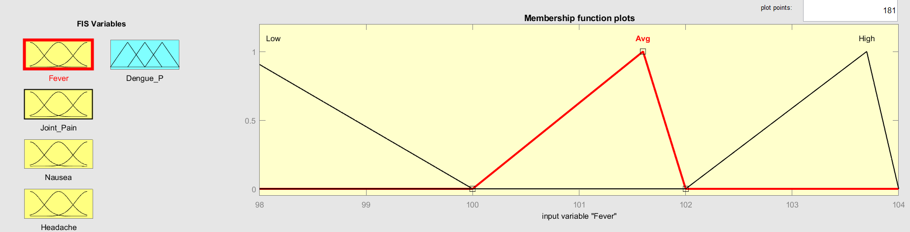

**Fig 2.1- Membership function of input1(Fever)**

* **Headache:-**Headaches are a very common condition that most people will experience many times during their lives. The main symptom of a headache is pain in your head or face. While most headaches aren’t dangerous, certain types can be a sign of a serious underlying condition.

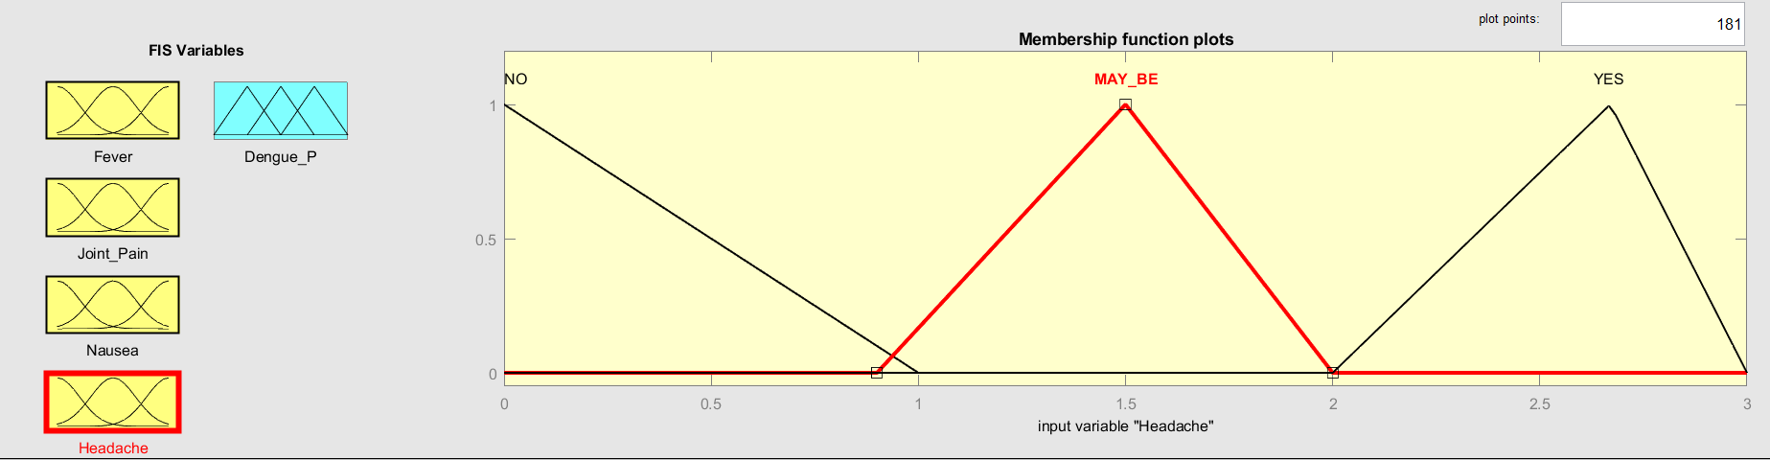

**Fig 2.2- Membership function of input2(Headache)**

* **Jointpain:-** Joint pain is common, especially as you get older. There are things you can do to ease the pain but get medical help if it's very painful or it does not get better**.**

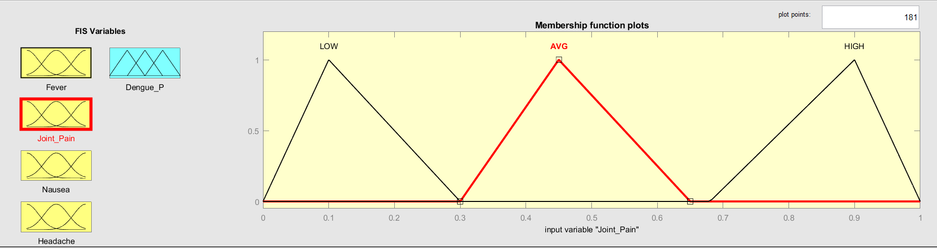

**Fig 2.3- Membership function of input3(Joint pain)**

* **Nausea**:-Nausea is stomach discomfort and the sensation of wanting to vomit. Nausea can be a precursor to vomiting the contents of the stomach. The condition has many causes and can often be prevented.

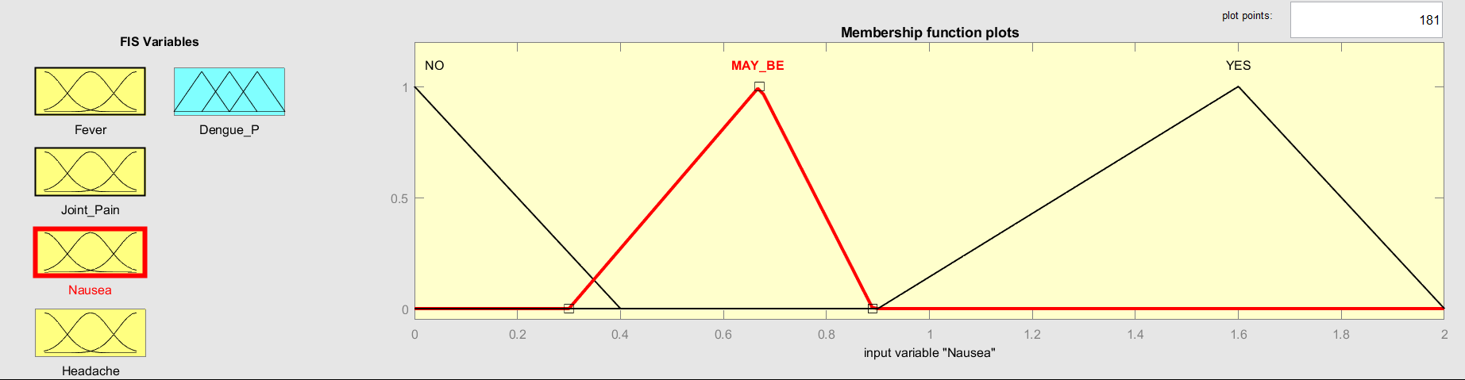

**Fig 2.4- Membership function of input4(Nausea)**

|  |  |
| --- | --- |
| Symptoms | Linguistics Variable |
| Fever | Low, Avg, High |
| Nausea | Low, Avg, High |
| Vomiting | No, may be, yes |
| Aches and Pains | No, may be, yes |

**Output :**Dengue Prediction Yes or No

* When we make all possible rules from input variable and set the range of all inputs then we find predicted Dengue or the chances of Dengue is **50%**. Where the value of

Fever = 100

Joint pain=0.46

Nausea=0.9 &

Headache=1.5

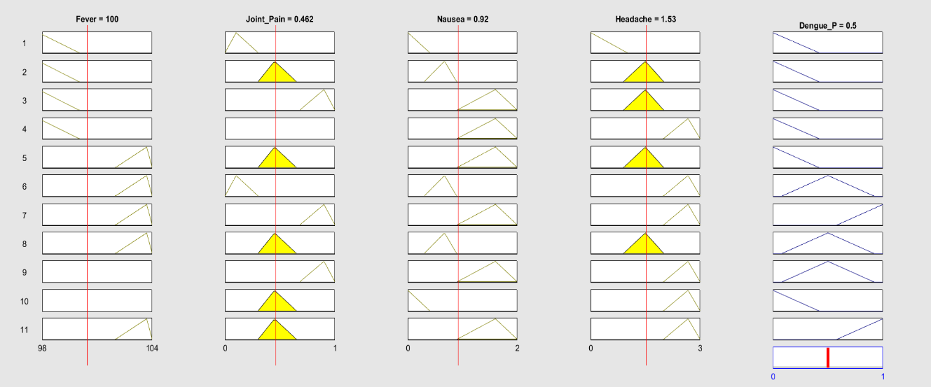

**Fig 3.1- Rule viewer of Dengue_P**

* When we set another values of input variable the chances of Dengue will change as shown in fig 3.2

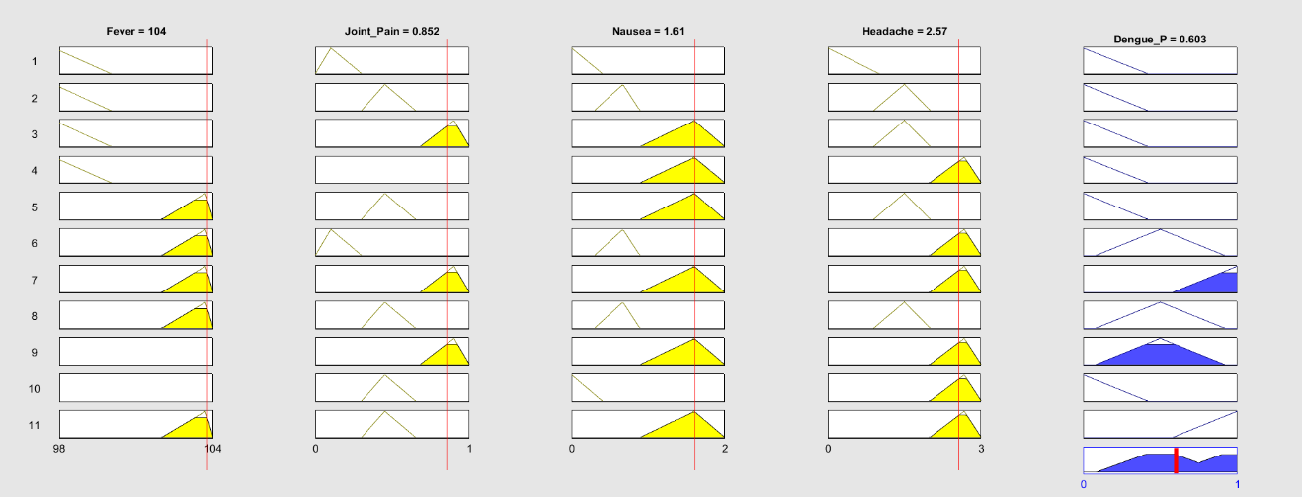

**Fig 3.2- Rule viewer of Dengue_P**

**Process:-**

This study proposes a system that will give notification for the patient whether they are infected with dengue fever or not by using a fuzzy logic approach as reference. There are several steps that involved in this study:

**Fuzzification**

The step in developing fuzzy logic is to set the fuzzy set. This process is called fuzzification. It evaluates the numerical input. By assigning the numerical values to the linguistics terms variable, evaluation phase can be perform. For this particular system, it uses yes, maybe and no. This is to cater with all the questions triggered by the system.

In this phase, it will define an input and output variables for the system and convert them into linguistics variables. Whereas in this system, the answer consist of a range of percentage which is zero to one hundred percent. Therefore the input which is being controlled by a slider will be set to a value from zero to one hundred.

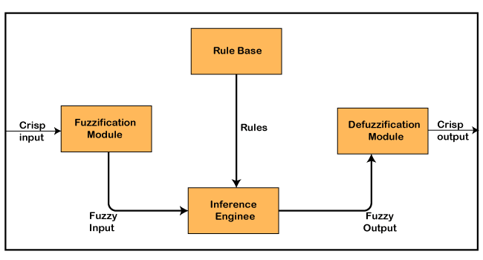

**Fig4 – Steps of Fuzzy logic**

**Fuzzy Inferencerule :-**Mamdani systems are composed of IF-THEN rule of the form “If X is A then Y is B” where First part is antecedent and second part is called consequent.

AS used in fuzzy rules for dengue prediction the rule s are given below:

If fever is low and joint pain is low and headache is low and nausea is low then dengue prediction is very low.

If fever is high and joint pain is high and headache is high and nausea is high then dengue prediction is very much,.

**Defuzzification:-**

Defuzzification is the last Phase of fuzzy logic.In this phase, is will show the output and being able to distinguish between which stages of the user level which is the patient status. This is either not necessary, have to notify or highly recommended.

**CHAPTER 4_______________________________________________________________**

### **4. Methodology:**

**4.1 Method**

Here is a general overview of the steps involved in using MATLAB for dengue prediction using fuzzy logic:

**1. Data collection:** Gather historical data related to dengue cases, including variables such as temperature, rainfall, humidity, and other relevant factors that influence the spread of dengue.

**2. Data pre-processing:** Clean and preprocess the collected data to remove any outliers, missing values, or inconsistencies. This step may involve data normalization or scaling to ensure that all variables are on a similar scale.

**3. Fuzzy logic modelling:** Define linguistic variables and their membership functions. Linguistic variables represent the input and output variables of the fuzzy system, such as temperature, rainfall, and dengue risk level. Membership functions describe the degree of membership of each data point to a particular linguistic term (e.g., "high," "low").

**4. Fuzzy rule base:** Develop a set of fuzzy rules that relate the input variables (e.g., temperature, rainfall) to the output variable (dengue risk level). These rules can be derived from domain expertise or through data-driven approaches such as fuzzy clustering or rule extraction algorithms.

**5. Fuzzy inference system:** Create a fuzzy inference system using MATLAB's Fuzzy Logic Toolbox. This system incorporates the linguistic variables, membership functions, and fuzzy rules to perform inference and make predictions based on the input data.

**6. Training and validation:** Split the available data into training and validation sets. Use the training set to optimize the parameters of the fuzzy logic system, such as the shape and position of membership functions, and adjust the weights of the fuzzy rules. Validate the model using the validation set to assess its predictive performance.

**7. Testing and evaluation**: Apply the trained fuzzy logic model to unseen data to predict the dengue risk level. Evaluate the model's performance using appropriate metrics such as accuracy, sensitivity, specificity, or area under the receiver operating characteristic (ROC) curve.

**4.2 Tools:**We have used MATLAB 2021 Version for dengue prediction using fuzzy logic. MATLAB provides various tools and functions for implementing fuzzy logic systems, making it a popular choice for developing fuzzy logic-based models for dengue prediction.

MATLAB provides a comprehensive set of functions for fuzzy logic modeling and inference, such as `fis`, `addmf`, `addrule`, and `evalfis`, among others. These functions allow you to define and manipulate fuzzy sets, construct fuzzy rule bases, and perform inference using various methods (e.g., Mamdani or Sugeno).

By leveraging MATLAB's capabilities, you can develop a dengue prediction model that incorporates fuzzy logic, helping to assess the risk and potential outbreaks of dengue based on the available data**.**

This version of MATLAB is 64-bit (win 64) i.e. R2021a (9.10.0.0.1602886).

**Fuzzy Logic Toolbox:** The Fuzzy Logic Toolbox is a software tool provided by MathWorks as a part of MATLAB, a popular programming and numerical computing platform. The Fuzzy Logic Toolbox allows users to design, simulate, and implement fuzzy logic systems for a wide range of applications.

Here are some key features and functionalities of the Fuzzy Logic Toolbox:

* **Fuzzy Inference Systems:** The toolbox enables the creation of fuzzy inference systems (FIS) using a graphical user interface or programmatically using MATLAB code. You can define fuzzy sets, membership functions, fuzzy rules, and input/output variables to build your fuzzy logic system.
* **Membership Functions:** The toolbox offers a variety of predefined membership functions, including triangular, trapezoidal, Gaussian, and custom shapes. You can also define your own membership functions to represent fuzzy sets.
* **Fuzzy Rule Editor**: The Fuzzy Logic Toolbox provides an interactive rule editor that allows you to define fuzzy rules using linguistic variables. You can specify rule antecedents and consequents using logical operators and linguistic terms.
* **Fuzzy Logic Operations**: The toolbox supports fuzzy logic operations such as fuzzy intersection, fuzzy union, fuzzy complement, and fuzzy composition. These operations allow you to combine fuzzy sets and perform calculations on fuzzy values.
* **Fuzzy Inference:** The toolbox includes methods for fuzzy inference, which involve the process of applying fuzzy rules to input data and obtaining crisp output values. It supports various inference methods like Mamdani, Sugeno, and Tsukamoto.
* **Defuzzification:** The Fuzzy Logic Toolbox provides defuzzification methods to convert fuzzy output values into crisp values. It supports common defuzzification techniques such as centroid, bisector, and weighted average.
* **Visualization:** The toolbox offers visualization tools to plot membership functions, fuzzy sets, rule surfaces, and output surfaces. You can visualize and analyse the behaviour of your fuzzy logic systems using these graphical representations.

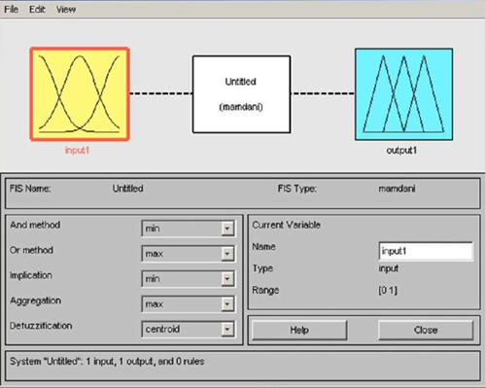

**Fig 5 - Fuzzy logic tool box**

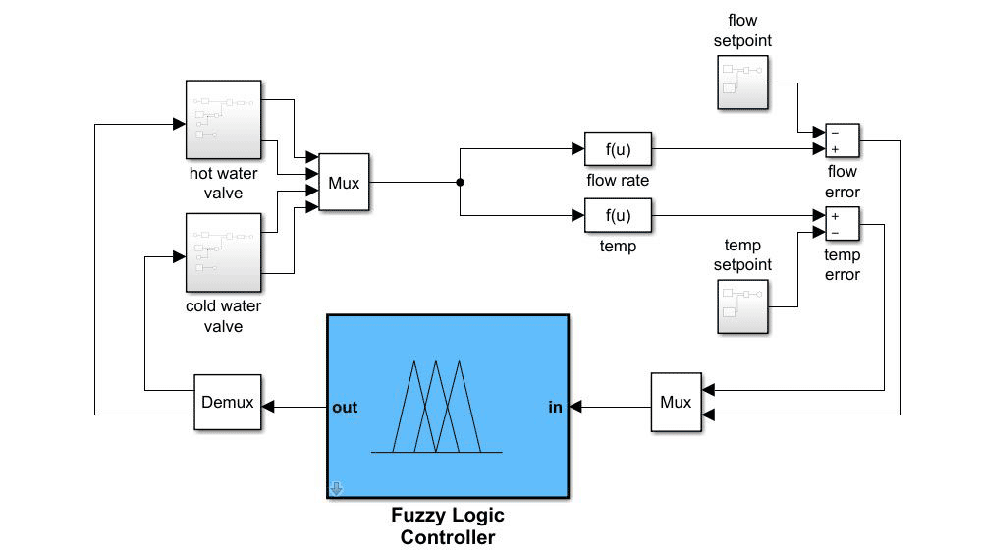

**Fig 6 – Fuzzy Logic toolbox for MATLAB**

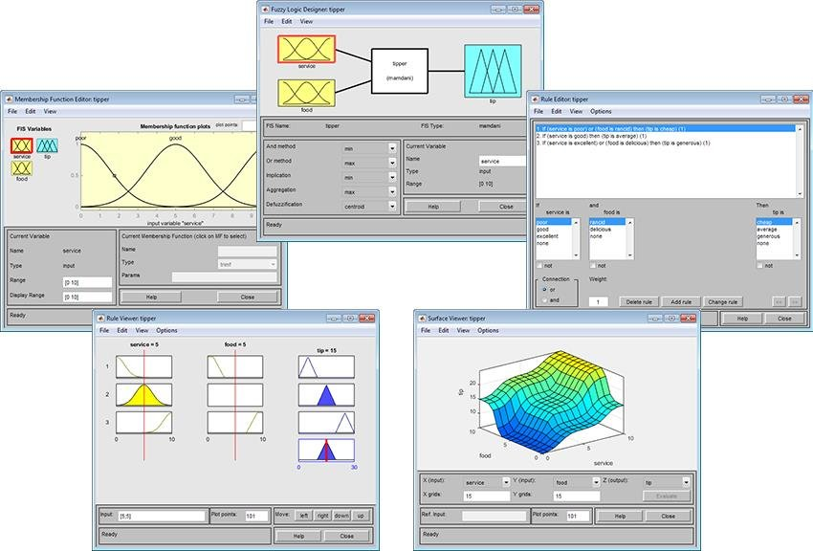

**Fig 7-Fuzzy logic toolbox views membership function editor**

**Chapter 5**

**Result –**

Development Fuzzy Inference System for dengue Prediction: afterdeterming the rules related to dengue prediction related input and its output for predicting dengue in fuzzy toolbox to be developed and where design membership of input and output.

All the four Linguisting input variable are used in FIS in Matlab 2019. The GUI fuzzy Logic toolbox using Matlab software is applied to create the FIS Dengue Prediction Model . In this Model MAMDANI Type of FIS is created

Fuzzy logic concept suggests a very different phenomena with a system when compared to the conventional method. To design the fuzzy logic system explores the problem rather than to model the system in mathematical expressions. The designed fuzzy logic-based dengue analysis proves to provide simplicity, less complexity and more efficiency to the user which is tough to obtain when using this. Its states the if and then rule. The result viewer figure depicts how the fuzzy logic base sentiment analysis is carried out based upon the input variable. The result is acquired primarily based on fuzzy if and then Mamdani rule base that is better than different choice.

* A dengue prediction system diagram typically consists of various components and their interactions, aimed at forecasting dengue outbreaks based on relevant data.

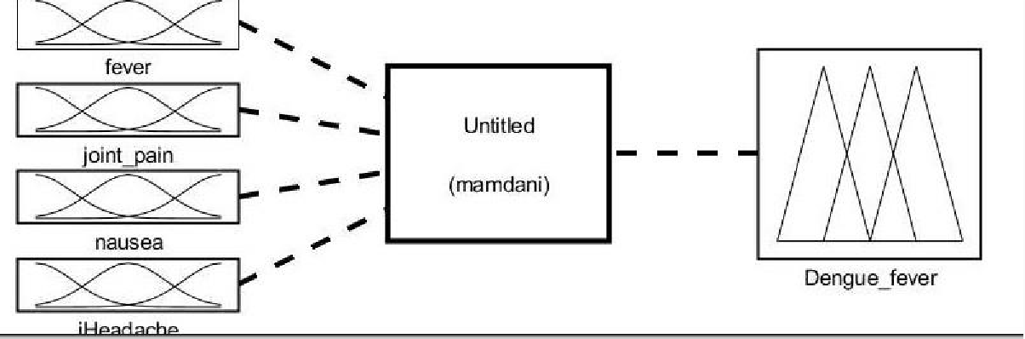

**Fig 8 – Dengue Prediction System**

* A fuzzy logic designer provides an interface or programming environment where users can define the variables, rules, and membership functions that constitute a fuzzy logic system. It typically includes functionalities for creating fuzzy sets, specifying membership functions, defining fuzzy rules, and conducting inference and defuzzification processes.

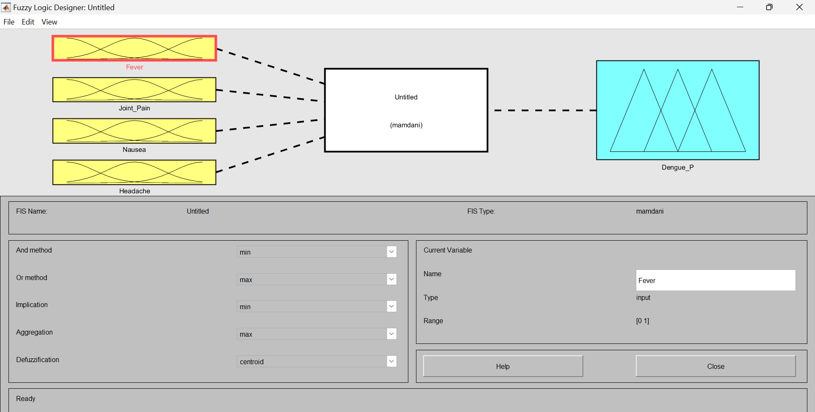

**Fig 9 – Fuzzy logic Designer**

* In a dengue prediction system, membership functions are used to represent the fuzzy sets associated with input variables. Fuzzy sets and membership functions are an essential part of fuzzy logic, allowing for the representation of uncertainty and imprecision in data. The specific membership functions used in a dengue prediction system can vary depending on the choice of input variables and the linguistic terms associated with them.

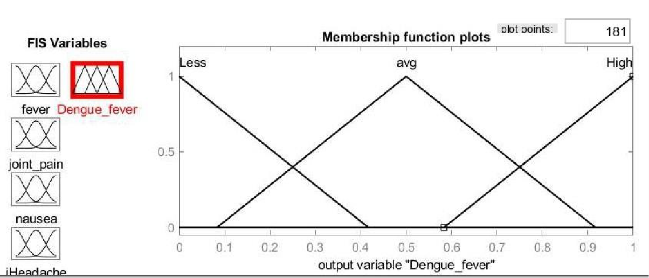

**Fig 10 – Membership function of Output**

* The rule editor is a component of a fuzzy logic system that allows users to specify the fuzzy rules that govern the behavior of the system. Fuzzy rules are used to represent the relationships between the input variables and the output variables of the system in linguistic terms.

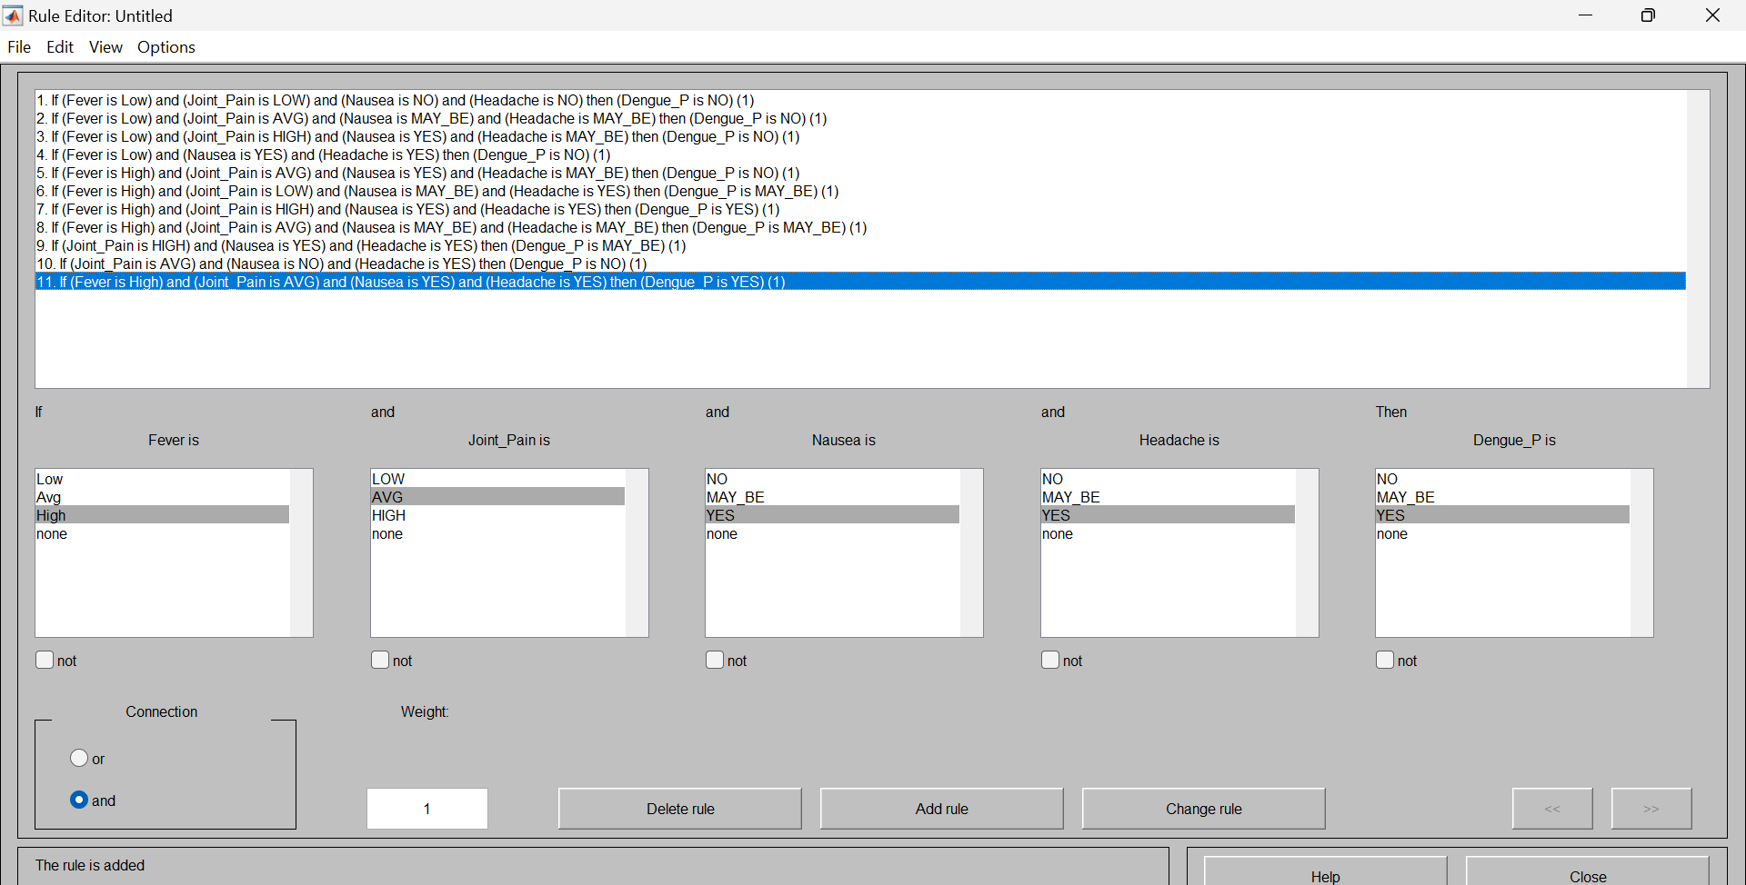

**Fig 11 – Rule Editor**

* When we make all possible rules from input variable and set the range of all inputs then we find predicted Dengue or the chances of Dengue is **50%**. Where the value of

Fever = 100

Joint pain=0.46

Nausea=0.9 &

Headache=1.5

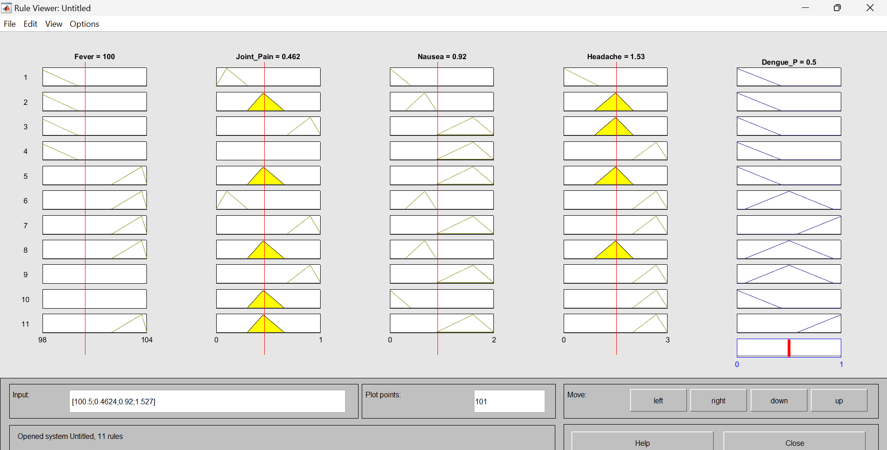

**Fig 12.1 – Rule viewer of Dengue_P**

* When we set another values of input variable the chances of Dengue will change as shown in fig 12.2.

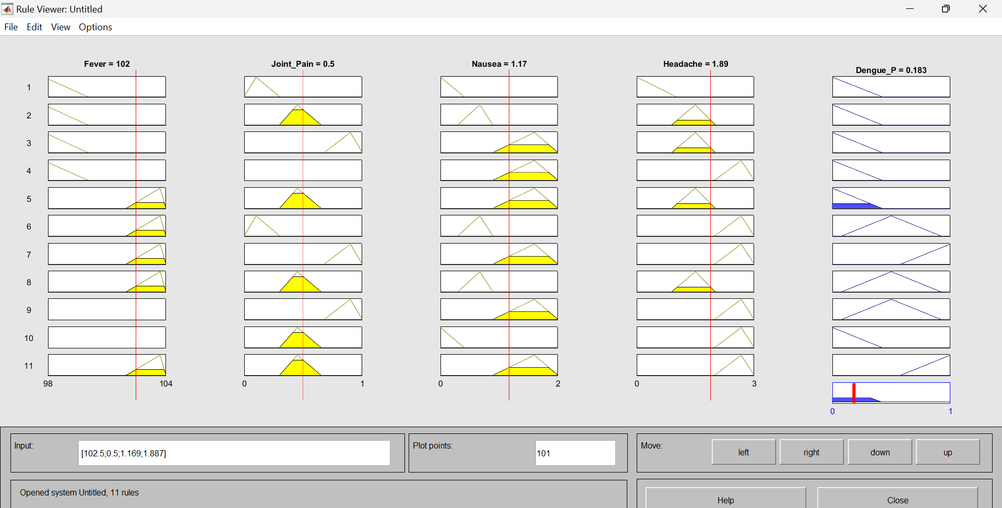

**Fig 12.2 – Rule viewer of Dengue_P**

* In a fuzzy logic system, the surface view refers to the graphical representation of the membership functions and the relationship between two input variables. Let's consider the joint pain and fever variables in a fuzzy logic system and elaborate on their surface view.

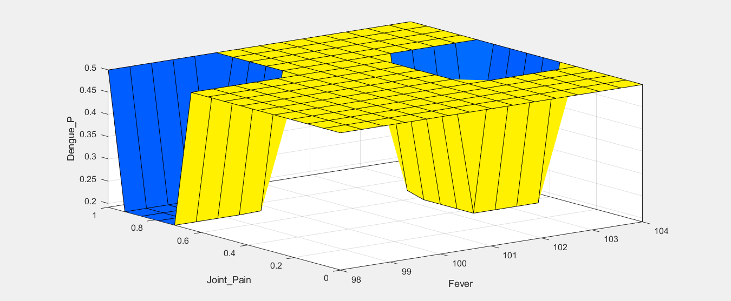

**Fig 13 -Surface view of Joint pain & Fever**

**Chapter 6**

**______________________________________________________________**

**Conclusion:-**

It may be Concluded from this Project for diagnosis for predicting of Dengue Fever the outcome achieved from proposed FIS model has more efficient as compare expert system. Now Days the advancement in computer science giving new technology in the field of medical area through there are various existing problem with real time information which have not being done. The proposed FIS technique deal with predicting of Dengue fever is depending upon the Patient data collected under the supervision of physician. he proposed FIS has been Simulated Using the performance Parameter as number of epoch and root mean square error. Simulation result shows that the Proposed technique FIS Shows a better outcome than existing expert system. In conclusion, dengue prediction using fuzzy logic offers a valuable approach to handle the uncertainty and imprecision associated with dengue-related factors. By modeling linguistic variables, fuzzy sets, and fuzzy rules, fuzzy logic provides a framework for capturing the complex relationships between environmental factors, mosquito population, and dengue incidence. Several studies have explored the application of fuzzy logic in dengue prediction, demonstrating its effectiveness in forecasting dengue outbreaks and aiding in decision-making.

**Future Work:-**

In this methodical review, the studies related to the employment of the fuzzy logic techniques in an infectious disease were assessed, and depending on the acquired outcomes, we can notice an interest amongst the researchers regarding this specific field of research. In last few years, a large number of the transmissible diseases that were supposed to be eliminated have made a comeback. Certain factors such as manufacturing, agricultural practices, wars, changes in lifestyles, development and urbanization, and environmental change are all effective in the appearance and reappearance of an infectious disease. This SLR’s result demonstrates that even though these are the most of the infectious diseases that were investigated, but there is still more area that needs to be covered. Nevertheless, more work should be carried out on the appearance and reappearance diseases domains such as H1N1, SARS, Zoonosis and the Rift valley fever.

Internationally, there is a lack of an integrated framework for reporting infectious disease. Additionally, an infectious diseases information system has an inadequate support for data analysis and generating predictive techniques centered on artificial intelligence. An integrated analytical framework that offers functions as in a progressive data analysis capability and a visualization support is of a critical importance. There is serious need for creating an atmosphere for collecting, distributing, reporting, assessing, and picturing the infectious disease data and to provide support for decision-making tools regarding disease prevention, recognition, and controlling.

Infectious disease observation and controlling has demanded an interdisciplinary work. To have the ability to achieve those objectives, the employment of Geographic Information Systems (GIS), three-dimensional information analysis, machine learning and visualization applications and techniques became a must.

Because of the significance of the infectious diseases at the global level, it is essential to simultaneously develop an incorporated infectious disease dataset and to make the specialized analytical and diagnostic methods all at the same time. Additionally, there was slight conversation in the incorporated literature about three-dimensional information analysis for an infectious disease occurrence. Three-dimensional information evaluation techniques may be useful in determining the concentration pattern of a disease occurrence and to make the required association from the determined patterns to the measureable procedures.

Future work in dengue prediction using fuzzy logic can focus on the following areas:

**Integration of additional variables**: Incorporating more relevant variables such as population density, land use patterns, and socio-economic factors can enhance the accuracy of dengue prediction models based on fuzzy logic. Exploring the impact of these variables and their fuzzy relationships can lead to more comprehensive and reliable predictions.

**Improving rule base and inference mechanisms**: Refining and expanding the rule base of fuzzy inference systems can enhance the prediction accuracy. Developing more sophisticated inference mechanisms, such as adaptive or self-learning approaches, can improve the performance of fuzzy logic-based models for dengue prediction.

**Validation and comparison with other methods**: Conducting extensive validation studies and comparing fuzzy logic-based approaches with other prediction methods, such as machine learning or statistical models, can provide insights into the strengths and limitations of fuzzy logic in dengue prediction. This can help identify scenarios where fuzzy logic excels and areas for further improvement.

**Real-time prediction and decision support**: Developing real-time prediction models using fuzzy logic can enable timely and proactive measures to control dengue outbreaks. Integrating the prediction models with decision support systems can assist public health authorities in implementing effective strategies for prevention, resource allocation, and targeted interventions.

**Geographic variations and scalability**: Investigating the applicability and scalability of fuzzy logic-based dengue prediction models across different geographical regions and varying climatic conditions can help determine their robustness and generalizability.

Overall, the use of fuzzy logic in dengue prediction holds promise for improving our understanding of the disease dynamics and enhancing our ability to forecast and mitigate dengue outbreaks. Further research and development efforts in these areas can contribute to more accurate and reliable dengue prediction models, supporting proactive public health measures and ultimately reducing the impact of dengue on affected communities.

**Reference: -**

1."Dengue and severe dengue Fact sheet N°117". WHO. May 2015. Archived from the original on 2 September 2016. Retrieved 3 February 2016.

2. Kularatne SA (September 2015)."Dengue fever". BMJ. 351: h4661.doi:10.1136/bmj.h4661. PMID 26374064. S2CID 1680504

3. World Health Organization, Dengue and severe dengue, 2018.

4. S. Bhatt, P. W. Gething, O. J. Brady et al., “The global distribution and burden of dengue,” Nature, vol. 496, no. 7446, pp. 504–507, 2013

5. N. K. Vaidya, X. Li, and F. B. Wang, “Impact of spatially heterogeneous temperature on the dynamics of dengue disease,” Discrete and Continuous Dynamical System Series B, vol. 24, no. 1, p. 321, 2019

6. R. N. Beers and S. M. Ciupe, “Modelling original antigenic sin in dengue viral infection,” Mathematical Medicine and Biology, vol. 35, no. 2, pp. 257–272, 2018.

7.Gubler DJ. Epidemic dengue/dengue hemorrhagic fever as a public health, social and economic problem in the 21st century. Trends Microbiol. 2002;10:100–3.

8.Gubler DJ. The changing epidemiology of yellow fever and dengue, 1900 to 2003: full circle? Comp Immunol Microbiol Infect Dis. 2004;27:319–30.

9.Delatte H, Gimonneau G, Triboire A, Fontenille D. Influence of temperature on immature development, survival, longevity, fecundity, and gonotrophic cycles of Aedes albopictus, vector of chikungunya and dengue in the Indian Ocean. J Med Entomol. 2009;46:33–41.

10.Aström C, Rocklöv J, Hales S, Béguin A, Louis V, Sauerborn R. Potential distribution of dengue fever under scenarios of climate change and economic development. EcoHealth. 2013;9:448–54.

11.Messina JP, Brady OJ, Pigott DM, Brownstein JS, Hoen AG, Hay SI. Global dengue occurrence database: 1960–2012. 2014. https://doi.org/10.6084/ m9.fgshare.902845. Accessed 1 Mar 2018

12.Morin CW, Comrie AC, Ernst K. Climate and dengue transmission: evidence and implications. Environ Health Perspect. 2013;121:1264–72.

13.Kraemer MU, Sinka ME, Duda KA, Mylne AQ, Shearer FM, Barker CM, et al. The global distribution of the arbovirus vectors Aedes aegypti and A. albopictus. eLife. 2015;4:e08347.

14.Kraemer MUG, Sinka ME, Duda KA, Mylne A, Shearer FM, Barker CM, et al. The global compendium of Aedes aegypti and Ae. albopictus occurrence. Sci Data. 2015;2:150035.

15.Zeller H, Van Bortel W, Sudre B. Chikungunya: its history in Africa and Asia and its spread to new regions in 2013–2014. J Infect Dis. 2016;214:436–40.

16.Campbell LP, Luther C, Moo-Llanes D, Ramsey JM, Danis-Lozano R, Peterson AT. Climate change infuences on global distributions of dengue and chikungunya virus vector. Philos Trans R Soc London B Biol Sci. 2015;370:20140135.

17.Gubler DJ, Vasilakis N, Musso D. History and emergence of Zika virus. J Infect Dis. 2017;216:860–7.

18.Brathwaite DO, San Martín JL, Montoya RH, del Diego J, Zambrano B, Dayan GH. Review: the history of dengue outbreaks in the Americas. Am J Trop Med Hyg. 2012;87:584–93.

19.Messina JP, Bradu OJ, Scott TW, Zou C, Pigott DM, Duda KA, et al. Global spread of dengue virus types: mapping the 70-year history. Trends Microbiol. 2014;22:138–46.

20.Salski A, Kandzia P. Fuzzy sets and fuzzy logic in ecological modelling. EcoSys. 1996;4:85–97.

21.Salski A, Kandzia P. Fuzzy sets and fuzzy logic in ecological modelling. EcoSys. 1996;4:85–97.

22.Salski A. Ecological applications of fuzzy logic. In: Recknagel F, editor. Ecological informatics: scope, techniques and applications. Berlin: Springer; 2006. p. 3–14

23.Real R, Barbosa AM, Vargas JM. Obtaining environmental favourability functions from logistic regression. Environ Ecol Stat. 2006;13:237–45.

24.Olivero J, Fa JE, Real R, Farfán MA, Márquez AL, Vargas JM, et al. Mammalian biogeography and the Ebola virus in Africa. Mammal Rev. 2017;47:24–37.

25.T.R. Razak, et al., " A Fuzzy Expert System for Early Symptoms Detection of Bird Flu Disease," in Humanities, Science and Engineering Research (SHUSER), 2013 IEEE Symposium on, 2013

26.Acevedo P, Ward AI, Real R, Smith GC. Assessing biogeographical relationships of ecologically related species using favourability functions: a case study on British deer. Divers Disturb. 2010;16:515–28.

27.Romero D, Báez JC, Ferri-Yáñez F, Bellido JJ, Real R. Modelling favourability for invasive species encroachment to identify areas of native species vulnerability. Sci World J. 2014;2014:519710.

28.Romero D, Olivero J, Brito JC, Real R. Comparison of approaches to combine species distribution models based on different sets of predictors. Ecography. 2016;39:561–71.

29.Romo H, García-Barros E, Márquez AL, Moreno JC, Real R. Efects of climate change on the distribution of ecologically interacting species: butterflies and their main food plant.

30.Barbosa AM. fuzzySim: applying fuzzy logic to binary similarity indices in ecology. Methods EcolEvol. 2015;6:853–8.

31.Sudhahar J., Poornima M., & Dharani S. (2018). A comprehensive survey on dengue prediction techniques in India. International Journal of Engineering and Technology, 7(3.7), 216-219.

32.Jena S. K., Pradhan S., Panigrahi S., & Mishra S. (2017). An improved model for dengue outbreak prediction using support vector machine. In Proceedings of the International Conference on Inventive Systems and Control (ICISC) (pp. 1-5). IEEE. doi: 10.1109/ICISC.2017.8068670

33.Mondal A., Chatterjee J., & Ghoshal N. (2017). Prediction of dengue outbreak in Kolkata, India: A time series modeling. Acta Medica International, 4(1), 64-68. doi: 10.5530/ami.2017.1.14

34.Mondal A., & Ghoshal N. (2017). A time series model for predicting dengue outbreak in the districts of West Bengal, India. International Journal of Scientific Research in Science, Engineering and Technology, 3(3), 325-331.

35.Patil A., Dhande P. P., Khedkar D. T., & Agrawal S. (2016). Predicting dengue outbreak in Pune, India using weather and nonweather factors. Journal of Vector Borne Diseases, 53(2), 143-149.

36.Rakesh P. S., & Indu R. (2016). Dengue outbreak prediction using time series modelling: A case study of Delhi, India. International Journal of Environmental Research and Public Health, 13(7), 665. doi: 10.3390/ijerph13070665

37.Dey P., Bhattacharya S., & Adhikari A. (2015). Forecasting and analysis of dengue cases in Chennai using ARIMA model. International Journal of Computer Applications, 118(5), 6-11. doi: 10.5120/20804-1072